Lab 2

109550087 單宇晟

1. Code

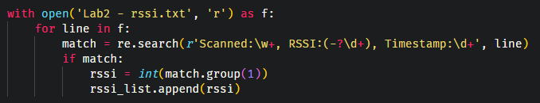

This is how I parse the rssi values. First, scroll through every line in the txt file, and if its format is same as what I want, I save the rssi value into a list using append(). This can ensure that all the rssi values in the list are in order.

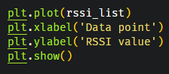

And this is how I plot the graph. Since TA said that the time doesn’t matter (but order does), I didn’t parse the time in the txt file. I simply let the number of data points became x – axis.

1. Discussion

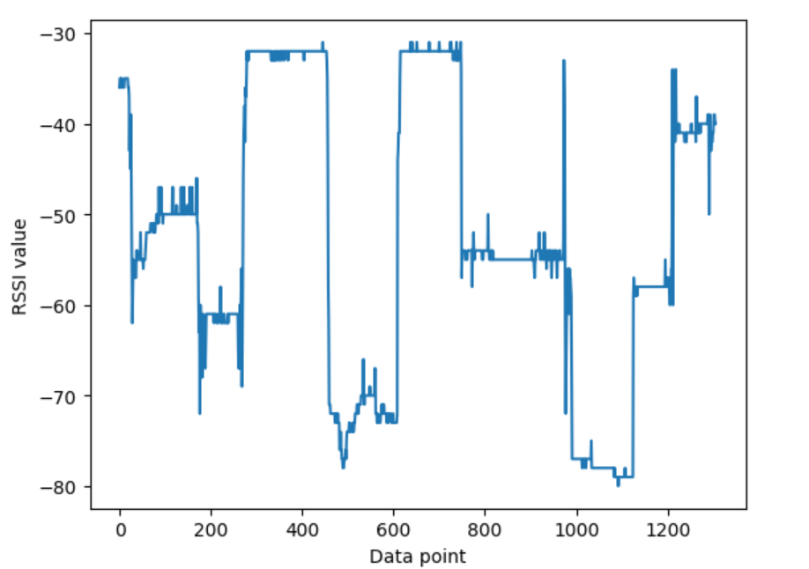

0 ~ 200

1. In the beginning, rssi drop from -35 to -60, this drop could be caused by a variety of factors, such as interference from other devices, physical obstructions, or changes in the environment.
2. Then rssi gradually rise from -60 to -50, I think this is because the distance between two point is getting shorter.
3. After a short time of stable rssi, it suddenly drop again. This situation is like (1), but I think the actual reason is different from (1). For instance, if the reason of (1) is an obstruction, (3) may be other reasons. This is because the effect of (1) still exist, so there must be a distinct, or another reason.

200 ~ 400

1. During this time slot, rssi rise significantly, I think the reason is that the effect of (1) and (3) has disappeared. For example, a moving obstruction has moved away, or a interference from another device has gone, too. Also, rssi is a little higher than the initial value, this may mean that the distance between two point is shorter than the initial distance. In fact, based on the observation on Monday, I think the distance between two points are almost zero.

400 ~ 600

1. Next comes a duration of stable situation again. After this, a significant drop occurred. The reason is similar to (1), but this time, those factors may occur at the same time, which lead to the sudden signal drop. Moreover, the signal is so low that I think the connection is almost gone. (訊號弱到快不見了)
2. Next, the signal gradually rise again, this is just like (2).

600 ~ 800

1. Now the signal climb up to around -30 again, I think this means the factors at (5) have gone at the same time, so the signal comes back to -30.
2. After a short time of stable signal, rssi drop from -30 to -55, this may means that there is a obstacle in the path, or the distance becomes further in a short time (if not, it should be gradually decrease).

800 ~ 1000

1. Next, rssi is very unstable, it first go up to -30, then drop to -70. I think this is what happen: First, the factor of (8) disappeared, and the distance between two points changes very fast (first close then far). Moreover, this time, rssi Is even weaker than (5), which is around -70. The connection is almost gone.

1000 ~ 1200

1. Then rssi climb up to -60, this may mean that the obstacle is gone, or the distance is closer.
2. Finally, rssi rise again, same as (10), I think the reasons are similar.